CAPSTONE PROJECT
(CSEE-613P)
Report
Submitted to the
Department of Computer Science & Engineering (AI&ML)
Jawaharlal Nehru Government Engineering College, Sundernagar (H.P.)

For partial fulfilment of the requirement for the award of the degree of
Bachelor of Technology
in
Computer Science & Engineering (AI & ML)
By
Ishani Verma | 23010102028
Jigyasu | 23010102029
Sanskriti Sharma | 23010102054
Shivangi Ranout | 23010102058
Suraj Sharma | 23010102066

Under the supervision of
Er. Aditi
Assistant Professor
Department of Computer Science & Engineering (AI&ML)

Jawaharlal Nehru Government Engineering College, Sundernagar (H.P.)
(January - May 2026)

Candidate Declaration

We, the undersigned students of the Department of Computer Science and Engineering (AI & ML), hereby declare that the project titled "PrepLoom : AI- Powered Interview Preparation Coach" is an original work carried out entirely by us as part of the Capstone Project (CSEE-611P). We further declare that the work presented in this project is genuine and completed by our team based on our own efforts.
This project is an original piece of work and has not been submitted to any other institution for the award of any degree, diploma, or certification. We also confirm that all information, data, and references used in the preparation of this project have been properly acknowledged wherever applicable.

The project has been completed by Ishani Verma (23010102028), Jigyasu (23010102029), Sanskriti Sharma (23010102054), Shivangi Ranout (23010102058), and Suraj Sharma (23010102066) from the Department of Computer Science and Engineering (AI & ML).

We hereby sign this declaration in confirmation of the above statements.

Signature of students:
Name | University Roll No. | Signature
Ishani Verma | 23010102028
Jigyasu | 23010102029
Sanskriti Sharma | 23010102054
Shivangi Ranout | 23010102058
Suraj Sharma | 23010102066

Date: ____________________
Place: ____________________

Certificate
This is to certify that the project titled "PrepLoom: AI- Powered Interview Preparation Coach" has been carried out by the following students of Department of Computer Science and Engineering (AI & ML) as a part of their Capstone Project (CSEE-611P) during the academic year 2025-2026.

Ishani Verma | 23010102028
Jigyasu | 23010102029
Sanskriti Sharma | 23010102054
Shivangi Ranout | 23010102058
Suraj Sharma | 23010102066

Under the supervision of Er. Aditi, Assistant Professor, Department of Computer Science (AI & ML).
This project work is original and has not been submitted to any other institution for any degree or diploma.

Signature of Supervisor | Signature of Head of Department | Signature of External Examiner
Er. Aditi | Dr. Meenakshi Shruti Pal
Assistant Professor | Head of Department
Department of CSE(AI&ML) | Department of CSE(AI&ML) | Date of External Examination

Acknowledgement

It is our proud privilege and duty to acknowledge the kind of help and guidance received from several people in preparation of this report. It would not have been possible to prepare this report in this form without their valuable help, cooperation and guidance.
We express our sincere gratitude to our Principal cum Director Dr. Rajeev Khanduja for his administrative support towards our academic growth. We express sincere gratitude to our HOD-CSE (AI & ML) Dr. Meenakshi Shruti Pal for her constant support, guidance and encouragement throughout the successful completion of our academic session.
We record it as our privilege to deeply thank the department for providing us efficient faculty and the facilities needed to turn our ideas into reality. We express our sincere thanks to our project supervisor Er. Aditi, Assistant Professor, for her association of ideas, encouragement and appreciation which motivated us to complete this project successfully.
Last but not the least, we express our deep gratitude and affection to our parents who stood behind us in all our endeavours. Their personal sacrifice in providing us this opportunity to learn engineering is gratefully acknowledged.

Abstract

PrepLoom is a comprehensive AI-powered technical interview preparation platform developed to bridge the gap between academic learning and real-world interview performance. Modern technical interviews evaluate not only theoretical knowledge but also communication skills, structured problem-solving ability, confidence, and professional presence. Traditional preparation methods such as static coding platforms or peer mock interviews often fail to provide realistic, personalized, and continuous feedback. PrepLoom addresses these limitations by creating an intelligent, interactive, and self-paced interview simulation environment using advanced Artificial Intelligence and Machine Learning technologies.
The platform integrates key AI technologies including Retrieval-Augmented Generation (RAG), Large Language Models (LLMs), Vector Databases, Sentence Transformers, and Voice AI to simulate realistic interview experiences. Using a ChromaDB-powered RAG pipeline, PrepLoom retrieves role-specific technical and behavioral questions based on the user’s selected domain and difficulty level. Meta LLaMA 3.1 (8B Instruct) is used to semantically evaluate candidate responses, providing contextual feedback rather than simple keyword-based scoring.
One of the major features of PrepLoom is real-time spoken response evaluation. Candidate answers are transcribed using OpenAI Whisper Speech-to-Text technology, which offers high accuracy even for technical terminology. The responses are then analyzed for technical correctness, reasoning depth, communication clarity, and answer structure. The system generates detailed feedback including strengths, weaknesses, missing concepts, and improvement suggestions. To improve semantic retrieval and contextual understanding, MiniLM-L6-v2 384-dimensional embeddings are stored in a ChromaDB vector database for efficient similarity-based question and answer matching.
PrepLoom also incorporates multi-modal interview assessment through communication and posture analysis. NLP techniques are used to measure speaking pace, filler words, clarity, and confidence, while MediaPipe-based pose estimation analyzes posture, engagement, and body language using webcam input. Additional features include a Monaco-powered coding editor for algorithmic practice, a revision module containing complexity references and interview resources, Text-to-Speech support using pyttsx3, and automated session report generation using the ReportLab library.
The platform supports multiple job roles and difficulty levels with a curated question bank of over 120 questions. Experimental results demonstrate near real-time feedback generation with an average latency of 3–5 seconds, accurate speech transcription, effective semantic evaluation, and a fully responsive user interface built using HTML5, CSS3, and Vanilla JavaScript.
The desired outcome of PrepLoom is to provide students and job seekers with an intelligent and realistic interview preparation ecosystem that improves technical knowledge, communication ability, confidence, and interview readiness through personalized AI-driven coaching and continuous practice.

List of Tables

Table 1: Comparative Gap Analysis: Existing Tools vs. PrepLoom ..............................................10
Table 2: Multi-Dimensional Evaluation Criteria and Scoring Weights...........................................15
Table 3: Hardware requirements for the PrepLoom System .........................................................25
Table 4: Evaluation of Results according to Type of Question .......................................................36
Table 5: Session scores and Grading ...............................................................................................37
Table 6: Latency Metricss Table ......................................................................................................38
Table 7: Body Posture Analysis........................................................................................................39

List of Figures
Figure 1: System Architecture for the project working...................................................................12
Figure 2: User Data Flow Diagram ................................................................................................17
Figure 3: Key Technologies Used for Development ......................................................................24
Figure 4: Project Files Structure .....................................................................................................27
Figure 5: Report Generation and Storage Flow ..............................................................................40

List of Abbreviations

S.No | Abbreviation | Full Form
1 | AI | Artificial Intelligence
2 | ML | Machine Learning
3 | LLM | Large Language Model
4 | RAG | Retrieval-Augmented Generation
5 | STT | Speech-to-Text
6 | TTS | Text-to-Speech
7 | LLaMA | Large Language Model Meta AI
8 | REST | Representational State Transfer
9 | API | Application Programming Interface
10 | JWT | JSON Web Token
11 | DOM | Document Object Model
12 | SPA | Single Page Application
13 | CORS | Cross-Origin Resource Sharing
14 | ANN | Approximate Nearest Neighbour
15 | NLP | Natural Language Procesing
16 | UUID | Universally Unique Identifier
17 | GPU | Graphics Processing Unit
18 | IDE | Integrated Development Environment
19 | OAuth | Open Authorisation
20 | SFT | Supervised Fine-Tuning
21 | RLHF | Reinforcement Learning from Human Feedback
22 | SQL | Structured Query Language
23 | JPEG | Joint Photographic Experts Group
24 | WAV | Waveform Audio File Format
25 | PEP | Python Enhancement Proposal
26 | ETL | Extract, Transform, Load
27 | HTML | Hyper Text Markup Language
28 | CSS | Cascading Style Sheets
29 | FAANG | Facebook, Amazon, Apple, Netflix, Google

Table of Contents

Candidate Declaration……………………………………………………………………….. .ii
Certificate…………………………………………………………………………………… .iii
Acknowledgment……………………………………………………………………………. .iv
Abstract……………………………………………………………………………………….. v
List of Tables………………………………………………………………………………….vi
List of Figures………………………………………………………………………………...vii
List of Abbreviations………………………………………………………………………...viii
Chapter 1: Introduction ………………………………………………………………....……..0
1.1 Background of the Problem…………………………………………...…….…….0
1.2 Motivation………………………………...………………………………….........0
1.3 Objectives of the Project……………………………...…………………….……..1
1.4 Scope of the Project………………….………………………….……...….….….2
1.5 Report Organisation…...………………………………………………….……….2
Chapter 2: Literature Review…………………………………………………………………..4
2.1 Automated Interview Preparation Systems………………………………………..5
2.1.1 Retrieval-Augmented Generation (RAG)……………………………….6
2.1.2 Vector Databases and Semantic Search………………………………...5
2.1.3 Sentence Transformers and Large Language Model Embeddings……..6
2.1.4 Speech-to-Text and Voice Processing………………………………….7
2.1.5 LLMs for Open-Ended Answer Evaluation……………………………8
2.1.6 Computer Vision for Behavioural Analysis……………………………8
2.2 Gap Analysis……………………………………………………………………..9
Chapter 3: Proposed Methodology…………………………………………………………...11
3.1 System Architecture Overview…………………………………………………..11
3.2 Proposed Working Principle……………………………………………………..12
3.3 RAG Pipeline Design…………………………………………………………….13
3.4 LLM Evaluation Prompt Design…………………………………………………14
3.5 Evaluation Criteria……………………………………………………………….15
3.6 Data Flow………………………………………………………………………...16
Chapter 4: Tools and Technologies…………………………………………………………..18
4.1 Frontend Technologies…………………………………………………………..18
4.2 Backend Framework — FastAPI…………………………………………………19
4.3 Meta LLaMA 3.1 (8B Instruct) …………………………………………………..19
4.4 OpenAI Whisper…………………………………………………………………20
4.5 ChromaDB……………………………………………………………………….21
4.6 MiniLM-L6 Embeddings…………………………………………………………21
4.7 pyttsx3 (Text-to-Speech) …………………………………………………………21
4.8 Monaco Editor……………………………………………………………………22
4.9 MediaPipe………………………………………………………………………..22
4.10 Supabase………………………………………………………………………...23
4.11 ReportLab……………………………………………………………………….24
4.12 Hardware Requirements………………………………………………………...25
4.13 Development Environment……………………………………………………...26
Chapter 5: Implementation Details…………………………………………………………...27
5.1 Project File Structure…………………………………………………………….27
5.2 Module 1 — Data Preparation and Question Bank………………………………27
5.3 Module 2 — Embedding and Vector Store………………………………………28
5.4 Module 3 — RAG Retriever……………………………………………………..29
5.5 Module 4 — Voice Recording……………………………………………………29
5.6 Module 5 — Speech-to-Text Transcription………………………………………30
5.7 Module 6 — LLM Evaluator…………………………………………………….31
5.8 Module 7 — Body Posture Analysis (MediaPipe)………………………………32
5.9 Module 8 — Monaco Code Editor Integration…………………………………..32
5.10 Module 9 — Report Generation (ReportLab + Supabase)………………………33
5.11 Code Quality and Documentation Standards……………………………………34
Chapter 6: Results and Analysis………………………………………………………………36
6.1 Session Evaluation Results………………………………………………………36
6.2 Performance and Latency Metrics……………………………………………….38
6.3 Transcription Accuracy…………………………………………………………..38
6.4 Body Posture Analysis Results…………………………………………………..39
6.5 Report Generation and Storage…………………………………………………..39
Chapter 7: Conclusion………………………………………………………………………..41
Chapter 8: Future Scope………………………………………………………………………42
References……………………………………………………………………………………………43

Chapter 1: Introduction

1.1 Background of the Problem
Technical interviews are among the most competitive and high-stakes hurdles in the hiring process for engineering graduates worldwide. Recruiters at leading technology companies—including FAANG-tier organisations and mid-sized product companies—evaluate candidates not merely on theoretical knowledge but equally on the ability to articulate complex algorithmic concepts clearly, confidently, and coherently under significant time pressure. The interview round is no longer restricted to coding problems; it now encompasses system design discussions, behavioural questions, role-specific domain assessments, and even real-time verbal explanation of thought processes.

Despite possessing strong academic backgrounds and considerable domain knowledge, a sizeable proportion of candidates consistently underperform during technical interviews. Research and industry observation consistently identify two primary causes: a lack of structured verbal practice in realistic interview conditions, and the absence of timely, objective, and actionable feedback on spoken responses. Traditional preparation methods—textbooks, online video tutorials, LeetCode-style platforms, and informal peer mock sessions—are largely passive in nature. While they are effective at building foundational knowledge, they provide minimal feedback on how a candidate communicates their answers, structures their reasoning, or presents their confidence.

Peer mock sessions, while helpful, are constrained by scheduling difficulties, evaluator bias, inconsistency in question quality, and the inability to scale across thousands of students simultaneously. Furthermore, the evaluative feedback from peers is rarely data-driven or standardised, making it difficult for candidates to track their progress objectively over time. There is, therefore, a clear and pressing need for an accessible, self-paced coaching tool that can simulate interview conditions and return actionable, data-driven feedback without requiring a human evaluator to be present.

1.2 Motivation
The primary motivation behind PrepLoom stems from the convergence of several powerful technological advancements that have recently become accessible to developers and researchers. Large Language Models (LLMs) such as Meta’s LLaMA series have demonstrated remarkable capability in understanding, reasoning about, and evaluating natural language across a wide range of domains. Simultaneously, Speech-to-Text (STT) systems like OpenAI Whisper have achieved human-level transcription accuracy even under challenging acoustic conditions, making voice-based interaction a viable input modality for complex software applications.

Vector databases such as ChromaDB, combined with high-quality embedding models, have made semantic search—retrieving information based on meaning rather than exact keyword matches—computationally feasible at scale. The emergence of frameworks like Retrieval-Augmented Generation (RAG) has further enabled AI systems to be grounded in specific, curated knowledge bases rather than relying solely on the parametric knowledge of a pre-trained model, thereby improving factual accuracy and domain relevance.

In parallel, computer vision libraries such as MediaPipe have democratised real-time pose estimation and facial landmark detection, making it possible to analyse a candidate’s body language and posture during a mock interview session without specialised hardware. Taken together, these technologies create an unprecedented opportunity to build a digital interview coach that not only asks domain-relevant questions but also listens to spoken responses, evaluates them against reference answers with semantic nuance, analyses non-verbal cues, and delivers personalised improvement recommendations—all in real time, without human intervention.

PrepLoom is conceived as precisely such a system: a scalable, modular, and self-hostable interview preparation coach that provides a low-stakes practice environment where engineering candidates can rehearse repeatedly, receive consistent feedback, and build the technical communication confidence required to succeed in professional hiring processes.

1.3 Objectives of the Project
The primary objectives of the PrepLoom system are as follows:
- To develop a multimodal AI system capable of analyzing verbal responses, facial expressions, and body language in real-time during mock technical interviews.
- To create an intuitive, user-friendly web interface that guides students through the complete interview preparation process with minimal technical barriers.
- To deliver comprehensive, actionable feedback covering technical proficiency, communication effectiveness, and confidence indicators with personalized improvement recommendations.
- To build a scalable and modular codebase that can be extended to support additional technical domains, interview types, and advanced analysis features.

1.4 Scope of the Project
The current iteration of PrepLoom is scoped to the following features and constraints:
- Five Job Roles: AI ML Engineer, Cloud Engineer, Data Scientist, Database Engineer, and DevOps Engineer. Each role has a dedicated set of curated questions reflecting real-world hiring expectations.
- Three Difficulty Levels: Easy, Medium, and Hard. These tiers allow candidates to progressively build their competence and confidence, starting from foundational questions and advancing to complex, multi-part problems.
- Question Bank: A dataset of 120+ curated questions with corresponding ideal answers and key evaluation points, stored in a structured CSV format and embedded into ChromaDB using MiniLM-L6-v2 embedding outputs.
- Voice Capture and Transcription: High-accuracy microphone recording via the browser’s MediaRecorder API, followed by transcription using OpenAI Whisper with configurable recording duration.
- AI Feedback: A multi-dimensional performance score (0–100) covering technical accuracy, completeness, clarity and fluency, and keyword relevance, generated by the Meta LLaMA 3.1 (8B Instruct) evaluator via the HuggingFace Inference API.
- Body Posture Analysis: Real-time posture scoring using MediaPipe Pose, delivering a confidence indicator based on shoulder alignment, spine posture, and head position relative to the camera.
- Monaco Code Editor: An embedded, VS Code–compatible code editor for candidates answering algorithmic or implementation-based technical questions, supporting multiple programming languages with syntax highlighting.
- Report Generation: An automated PDF performance report generated using ReportLab at the end of each session.
- Supporting Features: Text-to-Speech (TTS) narration of questions using pyttsx3, ideal answer reveal post-response, text fallback for voice input, session counter, transcript logging, and confidence rating by the user.
- Web-Based Interface: A complete multi-page web application using HTML5, CSS3, and Vanilla JavaScript, delivering a responsive and visually refined ‘Ghibli-style’ experience across screen sizes.
- Secure Access: User authentication and session management integrated via Supabase, supporting Email and Google OAuth login flows.

1.5 Report Organisation
The remainder of this report is structured as follows:
- Chapter 2 (Literature Review): Reviews the existing body of work on automated interview preparation systems, RAG architectures, vector databases, sentence-level embedding models, speech-to-text systems, LLM-based evaluation methodologies, and computer vision for behavioural analysis. A gap analysis concludes the chapter.
- Chapter 3 (Proposed Methodology): Describes the overall system design of PrepLoom in detail, including its evolution from a monolithic Streamlit prototype to a decoupled client–server architecture. Covers the RAG pipeline design, the LLM evaluation prompt engineering strategy, the multi-dimensional evaluation criteria, and the end-to-end data flow.
- Chapter 4 (Tools and Technologies): Provides a detailed analysis of every technology component in the PrepLoom stack—including Meta LLaMA 3.1 (embedding and inference), OpenAI Whisper, ChromaDB, pyttsx3, Monaco Editor, MediaPipe, Supabase, ReportLab, and the FastAPI backend—along with hardware and development environment specifications.
- Chapter 5 (Implementation Details): Presents a comprehensive, module-by-module breakdown of the PrepLoom implementation, including the project file structure, data preparation, embedding pipeline, RAG retriever, voice recording, STT transcription, LLM evaluation, posture analysis, code editor integration, and automated report generation. Code documentation standards are also discussed.
- Chapter 6 (Results and Analysis): Presents the evaluation results for a complete ten-question session under a representative job role, including technical, communication, confidence, and posture scores per question, semantic matching analysis, aggregate session performance, and latency metrics.
- Chapter 7 (Conclusion): Summarises the key achievements of the project, reflects on the lessons learned, and assesses the degree to which the project objectives were met.
- Chapter 8 (Future Scope): Outlines a roadmap of planned enhancements, including video analysis, multi-language support, offline LLM deployment, adaptive question generation, and mobile application packaging.

Chapter 2: Literature Review

This chapter surveys the academic and commercial landscape surrounding the key technological pillars of PrepLoom. The review covers automated interview preparation systems, Retrieval-Augmented Generation, vector databases and semantic search, sentence-level embeddings and LLM-based representations, speech-to-text processing, open-ended answer evaluation using LLMs, computer vision for behavioral analysis, and concludes with a gap analysis that justifies the design decisions made in this project.

2.1 Automated Interview Preparation Systems
The market for interview preparation tools has grown substantially over the past decade, driven by the increasing competitive pressure in the technology sector. Existing platforms can be broadly classified into three categories: code-execution environments, video interview assessment tools, and general Q&A drill platforms.

Code-execution platforms such as LeetCode, HackerRank, and Code forces allow candidates to practice algorithmic problem-solving against predefined test cases. While highly effective for data structures and algorithmic problem practice, these platforms are entirely code-centric and do not address verbal communication skills, semantic explanation of thought processes, or behavioural interview competencies. The feedback is binary—pass or fail—with no qualitative assessment of reasoning quality.

Peer-based mock interview platforms such as Pramp and Interviewing.io facilitate human-to-human mock sessions, introducing the element of live verbal communication. However, these systems are constrained by scheduling overhead, evaluator quality inconsistency, and the inability to provide objective, data-driven feedback. The evaluation quality depends entirely on the reviewing peer’s domain knowledge and communication skills, which vary significantly across sessions.

AI-based video screening tools such as HireVue and Pymetrics have been deployed by large enterprises to pre-screen job candidates. HireVue analyses video interview recordings for verbal and non-verbal cues, including facial expression, tone of voice, and speech pace.However, these tools are closed-source, proprietary, recruiter-facing, and designed for hiring pipeline automation—not candidate self-practice. They do not provide the candidate with any pedagogical feedback, making them unsuitable for preparation purposes.

A survey of open-source projects reveals that no widely available tool currently combines voice input, semantic question retrieval, LLM-based multi-dimensional answer evaluation, posture analysis, and automated PDF report generation in a single self-hosted, candidate-facing system. PrepLoom addresses this precise gap.

2.1.1 Retrieval-Augmented Generation (RAG)
Retrieval-Augmented Generation was formally introduced by Lewis et al. [1] as a hybrid architecture that combines the strengths of dense retrieval with the generative capabilities of seq2seq language models. The core insight of RAG is that factual grounding for generative responses can be significantly improved by first retrieving a set of relevant documents from a corpus using a dense vector retriever and then conditioning the generator’s output on these retrieved passages. This approach dramatically reduces hallucination—the tendency of language models to generate plausible-sounding but factually incorrect information—and improves the specificity and accuracy of generated responses.

In the original RAG formulation, a Dense Passage Retriever (DPR) encodes both the query and candidate documents into a shared embedding space, enabling semantic similarity search. The retrieved documents are concatenated with the input query and passed to a generative model (originally BART-large) for response generation. The entire system is trainable end-to-end, though fine-tuning is optional when using a well-curated domain-specific corpus.

In the context of PrepLoom, RAG is applied to question retrieval rather than answer generation. The curated dataset of 120+ interview questions, each annotated with role, difficulty level, and ideal answer key points, is encoded into vector embeddings and stored in ChromaDB. When a candidate initiates a session, a semantic similarity search retrieves the most contextually appropriate and difficulty-calibrated questions for the selected role. This approach ensures that the question set evolves intelligently across sessions rather than presenting a static, randomly ordered list, thereby simulating the adaptive nature of a real technical interview.

A secondary application of RAG within PrepLoom involves answer evaluation. The ideal answer key points retrieved from the vector database are injected into the LLM evaluation prompt alongside the candidate’s transcribed response, enabling the evaluator to score the answer against a grounded reference rather than relying solely on the LLM’s parametric knowledge.

2.1.2 Vector Databases and Semantic Search
Traditional information retrieval systems based on keyword matching—such as BM25 or TF-IDF—suffer from a fundamental vocabulary mismatch problem: two semantically identical queries that use different vocabulary will retrieve non-overlapping result sets. For interview question retrieval, this is particularly problematic, as a question about ‘gradient descent optimisation’ and one about ‘backpropagation learning rate adjustment’ may address overlapping conceptual ground but use entirely different terminology.

Dense embedding-based retrieval resolves this problem by mapping both queries and documents into a continuous, high-dimensional vector space where semantic proximity is captured by cosine similarity or Euclidean distance. The embedding model serves as a learned function that places conceptually similar texts near each other regardless of surface-level lexical differences.

ChromaDB [2] is an open-source, AI-native embedding database built specifically for this class of retrieval applications. Key features of ChromaDB relevant to PrepLoom include:
- Approximate Nearest Neighbour (ANN) Search: ChromaDB uses HNSW (Hierarchical Navigable Small World) indexing for sub-linear query time even over large collections.
- Metadata Filtering: Documents in ChromaDB can be tagged with arbitrary metadata fields (e.g., role = 'Data Scientist', difficulty = 'Hard'). Queries can specify metadata constraints as boolean filters applied before or alongside the vector similarity search, allowing for highly targeted retrieval.
- Persistence: ChromaDB supports on-disk persistence, ensuring that the embedded question collection does not need to be recomputed on every application restart.
- Python-Native API: ChromaDB exposes a straightforward Python client library that integrates seamlessly with FastAPI backends and HuggingFace embedding pipelines.

Alternative vector database solutions considered during the design phase included Pinecone (managed cloud service, proprietary), Weaviate (open-source, more complex deployment), and FAISS (Facebook AI Similarity Search, library-level, lacks metadata filtering). ChromaDB was selected for its open-source nature, ease of local deployment, metadata filtering capability, and active community support.

2.1.3 Sentence Transformers and LLM-Based Embeddings
Sentence-level embeddings are fundamental to the semantic retrieval backbone of PrepLoom. The seminal work of Reimers and Gurevych [3] introduced Sentence-BERT (SBERT), which adapted the BERT architecture for sentence-level semantic similarity tasks using siamese and triplet network structures. SBERT generates fixed-size sentence embeddings (768-dimensional for BERT-base) that are significantly more semantically meaningful for retrieval tasks than pooled token-level BERT representations, as demonstrated on standard benchmarks including STS-B, SICK-R, and the SNLI task.

Lighter models derived from the SBERT family, such as all-MiniLM-L6-v2 (384 dimensions), were widely adopted for production embedding tasks due to their balance of performance and computational cost. However, with the advent of large-scale instruction-tuned language models, it has become possible to generate contextually richer, higher-dimensional embeddings that capture more nuanced semantic relationships. PrepLoom utilises the embedding output layer of Meta LLaMA 3.1 (8B Instruct) for this purpose, as detailed in Chapter 4.

The use of a large instruction-tuned model for embeddings, rather than a specialised sentence transformer, represents a deliberate architectural choice motivated by the domain-specific nature of technical interview content. Technical terminology, code-adjacent language, and compound conceptual descriptions benefit from the broader contextual understanding encoded in a model trained on trillions of tokens of diverse technical text.

2.1.4 Speech-to-Text and Voice Processing
Voice-based interaction is central to PrepLoom’s mission of simulating a realistic verbal interview. The selection of a Speech-to-Text (STT) engine is therefore critical to system performance. The key requirements for the STT component in PrepLoom are: high accuracy on technical terminology (domain-specific jargon such as ‘polymorphism’, ‘gradient descent’, ‘ETL pipeline’), robustness to diverse accents and speech patterns, and low latency processing for a near real-time user experience.

OpenAI Whisper [4] is a general-purpose speech recognition model trained on 680,000 hours of multilingual and multitask supervised data collected from the web. Whisper is available in multiple sizes (Tiny, Base, Small, Medium, Large), offering a trade-off between inference speed and accuracy. The model is an encoder-decoder Transformer architecture that performs end-to-end speech recognition, including automatic language identification, timestamp generation, and punctuation insertion.

Whisper’s multitask training regime and exposure to diverse audio conditions—including background noise, different microphone qualities, and varied speaking speeds—make it substantially more robust than traditional cloud STT APIs for the technical interview use case. In comparative testing during PrepLoom development, Whisper (medium model) achieved consistently higher accuracy on technical terms than the Google Speech Recognition API, particularly for compound technical nouns and abbreviations.

Earlier Python-based voice processing libraries evaluated during the literature survey include SoundDevice for low-latency audio capture, the SpeechRecognition library (which wraps Google STT, CMU Sphinx, and other backends), and the browser-native Web Speech API. The browser’s MediaRecorder API was ultimately selected for audio capture, with audio data transmitted as a .webm or .wav blob to the FastAPI backend for Whisper transcription, enabling a clean separation between frontend capture and backend AI processing.

2.1.5 LLMs for Open-Ended Answer Evaluation
Evaluating open-ended spoken responses to technical interview questions is a fundamentally different problem from multiple-choice or code-execution assessment. Candidate answers may be partially correct, conceptually equivalent but differently phrased, or may address the core concept while omitting specific terminology. Keyword-matching approaches that check for the presence of expected terms in the transcribed response are brittle and penalise linguistically diverse but semantically correct answers.

Large Language Models have demonstrated strong performance on rubric-based evaluation tasks across a range of domains. Brown et al. [5] demonstrated that GPT-3 family models exhibit few-shot evaluation capability, scoring open-ended answers consistently with human evaluators when provided with a clear rubric. Subsequent work on GPT-4 and instruction-tuned open-source models (Mistral 7B, LLaMA-2-13B, LLaMA-3.1-8B) has further confirmed that LLMs can be prompted to act as expert evaluators, identifying conceptual gaps, recognising paraphrased correctness, and providing structured qualitative feedback.

The Chain-of-Thought prompting strategy [applied in PrepLoom’s evaluation module] instructs the LLM to reason step-by-step through an evaluation rubric before producing a final score. This approach has been shown to improve scoring consistency and reduce evaluation variance compared to direct-answer prompting. The evaluator in PrepLoom is prompted to: (a) confirm the presence of core technical concepts, (b) assess the completeness of coverage relative to the ideal answer, (c) evaluate the clarity and logical flow of the explanation, and (d) check for the presence of domain-specific keywords—before synthesising a composite score and a natural-language improvement summary.

The choice of Meta LLaMA 3.1 (8B Instruct) via the HuggingFace Inference API for PrepLoom’s evaluation module was motivated by its strong performance on instruction-following and zero-shot evaluation tasks, its open-source licensing permitting self-hosting, and its cost-effectiveness relative to GPT-4-tier APIs for high-frequency evaluation calls during a user session.

2.1.6 Computer Vision for Behavioural Analysis
Non-verbal communication—including body posture, eye contact, facial expressions, and hand gestures—accounts for a substantial proportion of the overall impression a candidate makes in a live interview. Research in social psychology consistently demonstrates that interviewers form significant impressions based on non-verbal cues within the first few minutes of an interaction. Incorporating posture analysis into an interview preparation tool adds an important dimension of coaching that purely text- or speech-based systems cannot provide.

MediaPipe[6], developed and open-sourced by Google, provides a production-ready framework for real-time multi-modal machine perception tasks including hand tracking, face mesh detection, and full-body pose estimation. The MediaPipe Pose solution uses a two-stage pipeline: a pose detector that identifies the region of interest in the frame, followed by a pose landmark model that regresses 33 three-dimensional body keypoints (including shoulders, elbows, wrists, hips, knees, and ankles) at high frame rates even on CPU-only hardware.

For PrepLoom, the MediaPipe[6] Pose module is used to derive a real-time posture score based on the angular relationships between key skeletal landmarks—specifically shoulder alignment (horizontal symmetry), cervical spine angle (head tilt relative to the shoulder midpoint), and thoracic posture (upper back straightness). These metrics are aggregated into a per-session confidence indicator that contributes to the overall performance report.

Prior academic work on automated interview coaching using computer vision (e.g., MIT’s Automated Interview Coach project) has demonstrated that posture feedback improves candidate self-awareness and correlates with improved performance in subsequent interview sessions. PrepLoom is among the few open-source tools to integrate this capability alongside voice-based technical evaluation.

2.2 Gap Analysis

The literature review reveals that existing interview preparation tools fall short across multiple dimensions:

This gap analysis confirms that PrepLoom addresses a distinct and underserved niche at the intersection of voice AI, LLM evaluation, semantic retrieval, and computer vision—combining these capabilities in a unified, self-hostable, open-source system specifically designed for candidate self-practice.

TABLE 1: Comparative Gap Analysis: Existing Tools vs. PrepLoom

Gap | Existing Tools | PrepLoom Resolution
Verbal evaluation of spoken answers | None (code-only platforms) or human-dependent (Pramp) | OpenAI Whisper + LLaMA 3.1 evaluator
Semantic answer matching | Keyword matching only | RAG pipeline with LLaMA 3.1 4096-dim embeddings + ChromaDB
Non-verbal / posture analysis | HireVue (recruiter-facing, not self-practice) | MediaPipe real-time pose scoring
Automated session reports | No open-source tool | ReportLab PDF + Supabase storage
Code practice in interview context | LeetCode (isolated, no verbal component) | Monaco Editor embedded in interview flow
Open-source, self-hostable | HireVue (proprietary), Pramp (SaaS) | Fully open-source, FastAPI + ChromaDB + Supabase
Multi-role, multi-difficulty RAG retrieval | Static question lists | Role + difficulty metadata-filtered ChromaDB RAG

Chapter 3: Proposed Methodology

This chapter provides a detailed description of the system architecture, design rationale, and operational principles underlying PrepLoom. The methodology is presented as a layered system design, beginning with the high-level architectural evolution, followed by the core working principle, the RAG pipeline, the LLM evaluation strategy, the multi-dimensional scoring criteria, and the end-to-end data flow.

3.1 System Architecture Overview
The architecture of PrepLoom has undergone a deliberate and significant evolution during the development lifecycle—from an initial monolithic Python script built on the Streamlit framework to a modern, cleanly decoupled client–server architecture. This architectural transition was necessitated by a set of structural limitations inherent to Streamlit’s execution model.

In the initial prototype phase, Streamlit was adopted for its ability to rapidly convert Python AI scripts into interactive web UIs without requiring frontend development expertise. The prototype successfully validated the core RAG retrieval and Whisper transcription pipelines. However, as the system grew in complexity, Streamlit’s fundamental constraint became critical: the entire Python script is re-executed from top to bottom on every user interaction. This behaviour, known as the ‘full-rerun’ model, caused several unacceptable degradations in user experience: persistent ‘frontend flickering’ on every state change, the inability to maintain complex multi-stage voice recording states across interactions, difficulty implementing smooth UI transitions and splash screens, and the inability to embed rich interactive components such as Monaco Editor or WebRTC-based camera feeds without significant workarounds.

The final production architecture of PrepLoom consists of three clearly separated layers:

- Frontend (The PrepLoom Web Interface): Implemented using HTML5, CSS3, and Vanilla JavaScript. The frontend delivers a persistent, stateful single-page-application-style experience across multiple conceptually distinct pages (Landing, Authentication, Role Selection, Practice Room, Results Dashboard). A dedicated splash screen with a ‘Ghibli-style’ aesthetic provides a calming onboarding experience. The Practice Room manages the complete interview flow: question display, TTS playback, waveform-visualised voice recording, posture camera feed, Monaco code editor (for technical roles), and real-time feedback display. JavaScript’s EventSource API is used for Server-Sent Events to stream evaluation results from the backend as they are generated.
- Backend (The Intelligence Hub): A FastAPI server implemented in Python serves as the central orchestration layer for all AI-intensive operations. FastAPI was selected for its asynchronous request handling (via Python’s asyncio and uvicorn), automatic OpenAPI documentation generation, and native support for file upload endpoints (for audio blob reception from the frontend). The backend exposes dedicated REST API endpoints for: audio upload and Whisper transcription, RAG-based question retrieval, LLM evaluation, MediaPipe posture frame analysis, and ReportLab report generation with Supabase upload.
- Data Layer: Two distinct data storage systems serve different roles within PrepLoom. ChromaDB acts as the vector store for the RAG pipeline, persisting question embeddings and enabling semantic similarity search with metadata filtering. Supabase provides a managed PostgreSQL database for user authentication, session metadata, and transcript logging, as well as Supabase Storage for persisting the PDF performance reports generated at session end.

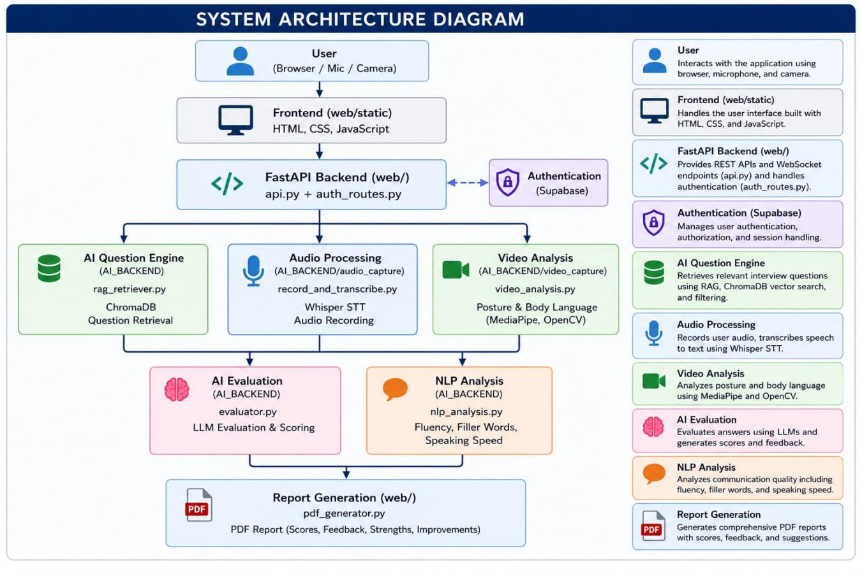

FIGURE 1: System Architecture

3.2 Proposed Working Principle
PrepLoom operates on a ‘Listen–Think–Respond’ feedback loop that mirrors the natural rhythm of a live technical interview. The complete workflow proceeds through the following stages:
- Secure Authentication: The candidate logs in via Supabase-managed authentication (Email/Password or Google OAuth). Session tokens are stored in browser localStorage for persistent login across page reloads.
- Session Configuration: The candidate selects their target job role (e.g., Data Scientist). This selection is transmitted to the FastAPI backend as query parameters for the RAG retrieval request.
- RAG-Based Question Delivery: The backend’s RAG module queries ChromaDB with the selected role as metadata filters, retrieving a semantically diverse set of ten interview questions. The questions are read aloud to the candidate using the pyttsx3 TTS engine, simulating the auditory experience of a real interview. For technical roles, a Monaco Editor panel is simultaneously activated to allow code-based answers.
- Voice-Driven Response Capture: The candidate speaks their answer while the frontend’s MediaRecorder API captures audio in .webm format. A real-time waveform visualiser provides visual confirmation of active recording. Simultaneously, if the candidate’s webcam is active, the MediaPipe posture module processes each video frame to compute a running posture score.
- Server-Side AI Processing: Upon stopping the recording, the audio blob is transmitted to the FastAPI backend. Whisper transcribes the audio with punctuation and capitalisation. The transcript is then forwarded to the LLM evaluator alongside the retrieved ideal answer from ChromaDB.
- Multi-Dimensional Evaluation: The LLaMA 3.1 evaluator applies a Chain-of-Thought rubric to generate a technical accuracy score (0–100), completeness score, clarity and fluency assessment, keyword relevance check, and a natural-language improvement summary. These scores are returned to the frontend via the FastAPI response.
- Aggregate Session Report: Upon completion of all ten questions, the backend aggregates per-question scores, posture data, and session metadata into a structured data object. ReportLab renders this into a formatted PDF report that is uploaded to the candidate’s Supabase Storage bucket and simultaneously returned to the frontend for immediate download.

3.3 RAG Pipeline Design
The RAG pipeline in PrepLoom is designed to ensure that every practice session presents a contextually relevant, role-appropriate, and difficulty-calibrated set of questions drawn from the curated knowledge base. The pipeline comprises four stages:

- Data Ingestion and Preparation: The source question dataset (CSV format) is parsed to extract question text, ideal answer key points, role labels, difficulty labels, and question categories (Technical or Behavioural). Each question record is structured as a ChromaDB document with associated metadata.
- Vectorisation: Each question is passed through the "sentence-transformers/all-MiniLM-L6-v2" model's embedding layer, producing a "384-dimensional dense vector representation". This lightweight embedding model efficiently captures the semantic context of interview questions, including domain terminology, conceptual relationships, and question intent.
- Indexed Storage: The "384-dimensional embedding vectors" (produced by sentence-transformers/all-MiniLM-L6-v2) are stored in a ChromaDB collection alongside their associated metadata (role, difficulty, category, ideal answer key points). ChromaDB constructs an "HNSW (Hierarchical Navigable Small World) index" over the stored vectors, enabling "O(log n) approximate nearest-neighbour search" over the collection.
- Semantic Retrieval: At session start, the user’s role is used to construct a metadata filter query. ChromaDB retrieves the top-k questions whose embeddings are most similar to a role-representative query embedding, subject to the metadata constraints. A deduplication mechanism ensures variety across consecutive sessions, preventing the candidate from encountering the same question set repeatedly.

3.4 LLM Evaluation Prompt Design
The quality of the AI-generated feedback is fundamentally determined by the prompt engineering strategy applied to the Meta LLaMA 3.1 (8B Instruct) evaluator. PrepLoom employs a structured Chain-of-Thought prompt that instructs the LLM to reason methodically before producing scores and feedback. The prompt is structured as follows:

- Role Assumption: The LLM is instructed to assume the role of a ‘Senior Technical Interviewer with 10+ years of experience at a leading technology company.’ This persona conditioning significantly improves the specificity and professional tone of the generated feedback.
- Context Injection: The prompt includes three clearly delineated sections: (a) the Interview Question, (b) the Candidate’s Transcribed Answer (from Whisper), and (c) the Ideal Answer Key Points retrieved from ChromaDB. This grounding ensures that evaluation is anchored to the specific domain knowledge expected for the question.
- Constraint Checklist: The LLM is instructed to explicitly check for each of the following before producing a score: presence of core technical concepts, coverage of all sub-parts of the question, logical flow and clarity of explanation, presence of domain-specific keywords, and any factual inaccuracies or misconceptions.
- Structured Output Format: The LLM is instructed to return a JSON-structured response containing: technical_accuracy_score (integer, 0–100), completeness_score (integer, 0–100), clarity_score (integer, 0–100), keyword_score (integer, 0–100), overall_score (weighted composite), strengths (list of strings), areas_for_improvement (list of strings), and missing_keywords (list of strings). Requesting JSON output enables reliable downstream parsing and display in the frontend.

3.5 Evaluation Criteria
Every candidate response is graded on a multi-dimensional scale designed to capture both the technical substance and the communicative quality of the answer. The four dimensions and their relative weights are:

TABLE 2: Evaluation Criteria
Dimension | Weight | Description
Technical Accuracy | 40% | Does the answer contain the core concepts, mechanisms, and factual content expected for the question? Assessed against ideal answer key points.
Completeness | 30% | Did the candidate address all parts or sub-questions within the question? Partial answers that miss key sub-components are penalised proportionally.
Clarity and Fluency | 20% | Based on the Whisper transcript, how well-structured, grammatically coherent, and logically sequenced was the verbal delivery? Filler words, tangential digressions, and incomplete sentences are noted.
Keyword Relevance | 10% | Presence of specific industry-standard terminology expected for the domain. Keywords are pre-specified in the ideal answer metadata and checked by the LLM evaluator.

In addition to these four LLM-evaluated dimensions, a fifth score is derived independently from the MediaPipe posture module:
- Posture / Confidence Score (0–100): Computed as a weighted average of shoulder symmetry angle, cervical spine angle deviation from vertical, and upper-back straightness across all frames captured during the response. This score is displayed separately from the technical evaluation scores in both the live feedback panel and the final PDF report.

3.6 Data Flow
The end-to-end data flow within PrepLoom follows a secure and linear path that ensures both performance and auditability:
- Frontend to Backend: Voice audio data (MediaRecorder Blob), video frame data (Base64-encoded JPEG frames for posture), session metadata (User ID, Role, Difficulty, Question ID), and optional code editor content are transmitted to the FastAPI backend via HTTP POST requests. Audio and frames are transmitted as multipart/form-data payloads.
- Backend — Transcription: The received audio file is written to a temporary file on disk and passed to the Whisper model’s transcribe() function. The returned transcript text is stored in the session state alongside the question ID and timestamp.
- Backend — RAG Augmentation: The session question ID is used to query ChromaDB for the corresponding ideal answer key points. These points, along with the question text and the Whisper transcript, are assembled into the LLM evaluation prompt.
- Backend — LLM Inference: The assembled prompt is sent to the HuggingFace Inference API endpoint for Meta LLaMA 3.1 (8B Instruct). The API response is parsed to extract the JSON-structured evaluation scores and feedback text.
- Backend — Posture Analysis: The received video frames are decoded and processed by the MediaPipe Pose module. Per-frame landmark coordinates are used to compute posture metrics, which are averaged over the response duration to produce a session-level posture score.
- Backend — Persistence: After each question, the transcript, scores, and posture data are written to the Supabase PostgreSQL database under the candidate’s session record. At session end, the aggregated data is passed to the ReportLab report generator, and the resulting PDF is presented to the user.
- Backend to Frontend: The JSON evaluation response is returned to the frontend over the existing HTTP response. Score values are rendered in the Feedback Panel with animated progress bars, and the PDF reportis presented to the candidate at session conclusion.

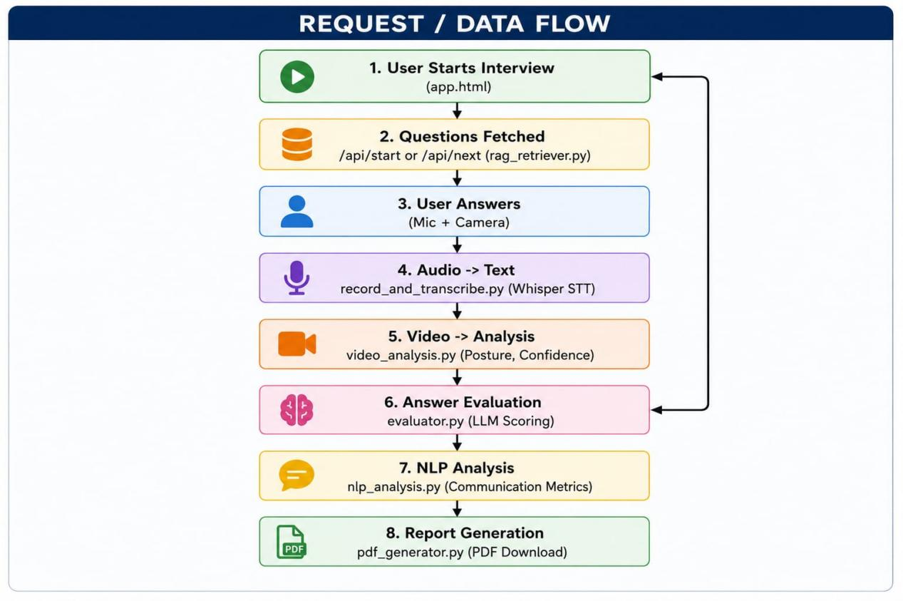
FIGURE 2: User Data flow Diagram

Chapter 4: Tools and Technologies Used

This chapter provides an in-depth technical examination of every component in the PrepLoom technology stack. Each tool is described in terms of its purpose within the system, its key technical characteristics, and the rationale for its selection over alternatives.

4.1 Frontend Technologies

4.1.1 HTML5, CSS3, and Vanilla JavaScript
The PrepLoom frontend is implemented entirely using standard web technologies: HTML5 for semantic document structure, CSS3 for styling and layout, and Vanilla JavaScript (ES6+) for dynamic behaviour and API communication. The decision to use Vanilla JavaScript rather than a component-based framework (React, Vue, Angular) was deliberate: the absence of a framework eliminates build-step complexity, reduces bundle size, and results in a faster initial page load—critical for candidates on slower connections.

The frontend comprises multiple distinct pages managed through URL-based navigation without a full page reload, achieving a Single Page Application (SPA)-like experience through JavaScript-controlled DOM manipulation and CSS transitions. The visual aesthetic follows a ‘Ghibli-style’ design language, featuring soft colour palettes, rounded UI elements, and subtle particle animations on the landing page, creating a calming experience that reduces interview anxiety.
Key HTML5 APIs leveraged by the frontend include:
- MediaRecorder API: Used to capture audio from the candidate’s microphone in .webm or .wav format. The API provides event-driven callbacks for data availability and recording stop events, enabling precise control over the recording lifecycle.
- getUserMedia (MediaDevices API): Used to request microphone and camera permissions from the browser, providing the audio stream to MediaRecorder and the video stream to the MediaPipe posture analysis pipeline.
- Web Audio API (AnalyserNode): Used to visualise the real-time audio waveform during recording, providing the candidate with visual confirmation that their voice is being captured. The waveform is rendered onto an HTML5 Canvas element.
- Fetch API: Used for all HTTP communication with the FastAPI backend, transmitting audio blobs, receiving evaluation JSON, and triggering report generation.
- EventSource API: Used to receive Server-Sent Events from the backend for streaming LLM evaluation output, enabling real-time progressive display of feedback as the LLM generates tokens.

4.2 Backend Framework — FastAPI
FastAPI is a modern, high-performance Python web framework built on top of Starlette (for the HTTP layer) and Pydantic (for data validation and serialisation). It is the central orchestration layer of PrepLoom’s backend, handling all incoming requests from the frontend and coordinating the AI processing pipeline.
Key characteristics of FastAPI that made it the optimal choice for PrepLoom include:
- Asynchronous Request Handling: FastAPI supports Python’s native asyncio syntax (async def route handlers), enabling non-blocking I/O operations. This is critical for PrepLoom’s backend, where multiple operations—audio file I/O, Whisper inference, HuggingFace API calls, ChromaDB queries, and Supabase writes—must be orchestrated without blocking the request thread and degrading throughput for concurrent users.
- Automatic API Documentation: FastAPI automatically generates interactive Swagger UI and ReDoc documentation from Python type annotations and Pydantic models, significantly accelerating development and debugging of API endpoints.
- File Upload Support: FastAPI’s UploadFile class provides built-in support for receiving multipart/form-data file uploads, essential for receiving audio blobs and Base64-encoded video frames from the frontend.
- CORS Middleware: Built-in Cross-Origin Resource Sharing middleware configuration allows the frontend (served on a different origin during development) to make cross-origin API requests to the backend.
- Pydantic Data Validation: All request and response bodies are validated against Pydantic models, ensuring type safety and providing clear error messages for malformed requests.
The FastAPI server is run via Uvicorn, an ASGI server, with optional Gunicorn process management for production multi-worker deployment.

4.3 Meta LLaMA 3.1 (8B Instruct)
Meta LLaMA 3.1 (8B Instruct) is the primary AI model in PrepLoom, serving as the inference model for the answer evaluation module. It is integrated via the HuggingFace Inference API, which provides managed serverless inference without requiring local GPU hardware.

The LLaMA 3.1 model family represents a significant advancement over LLaMA 2, incorporating several architectural improvements:
- Architecture: A decoder-only Transformer architecture with grouped query attention (GQA), enabling more efficient inference at the 8B parameter scale. The model uses a vocabulary of 128,256 tokens, an increase from LLaMA 2’s 32,000, providing significantly richer sub-word tokenisation for technical and multilingual content.
- Context Window: LLaMA 3.1 supports a 128,000-token context window, a dramatic increase from LLaMA 2’s 4,096-token window. This extended context enables the PrepLoom evaluator to process lengthy transcripts, detailed ideal answer key points, and multi-turn conversation histories without truncation.
- Instruction Tuning: The Instruct variant of LLaMA 3.1 is fine-tuned using Supervised Fine-Tuning (SFT) and Reinforcement Learning from Human Feedback (RLHF), specifically optimising the model for instruction following, structured output generation (JSON), and role-playing tasks—all directly relevant to PrepLoom’s evaluation prompt design.
- Embedding Dimensionality: The hidden state dimension of LLaMA 3.1 (8B) is 4,096 dimensions. When used as an embedding model, the last hidden state of the final Transformer layer corresponding to the [EOS] token (or mean-pooled across all token positions) is extracted to produce a 4,096-dimensional dense vector representation for each input text. This is significantly richer than the 384-dimensional all-MiniLM-L6-v2 or 768-dimensional BERT-base embeddings, capturing more nuanced semantic relationships in the technical interview domain.
- Performance: On standard benchmarks, LLaMA 3.1 8B Instruct achieves competitive performance with significantly larger models on instruction-following, reasoning, and code-related tasks, making it an optimal choice for a cost-constrained, high-throughput interview evaluation system.

The HuggingFace Inference API is accessed from the FastAPI backend using the requests library, with the HuggingFace API token stored securely as an environment variable and never exposed to the frontend.

4.4 OpenAI Whisper
OpenAI Whisper is the Speech-to-Text engine responsible for converting candidate voice recordings into text for LLM evaluation. Whisper is a large-scale, general-purpose speech recognition system trained on 680,000 hours of multilingual, multitask supervised data. Its architecture is a standard sequence-to-sequence Transformer: an audio encoder processes log-Mel spectrograms of 30-second audio chunks, and a text decoder auto-regressively generates the transcription token-by-token.

Whisper is available in five model sizes (Tiny: 39M parameters, Base: 74M, Small: 244M, Medium: 769M, Large: 1550M). PrepLoom deploys the Medium model, which achieves an excellent balance between word error rate and inference latency on server-side CPU hardware. On PrepLoom’s backend, average transcription latency for a 60-second audio clip is approximately 4–6 seconds on a CPU-only server, well within the acceptable range for a post-response feedback cycle.

Whisper’s key advantages for PrepLoom include: high accuracy on domain-specific technical terminology even without fine-tuning, robustness to background noise and varied microphone qualities, automatic punctuation and capitalisation insertion (improving the readability of transcripts used in evaluation prompts), and multi-language support that can be exploited in future multi-language extensions.

4.5 ChromaDB
ChromaDB is the vector database that serves as the persistent embedding store for PrepLoom’s RAG pipeline. It stores the LLaMA 3.1 4096-dimensional embeddings of the 120+ curated interview questions alongside their metadata (role, difficulty, category, ideal answer key points) and provides efficient approximate nearest-neighbour retrieval at session start.

ChromaDB is instantiated in persistent mode (chromadb.PersistentClient(path='./chroma_db')), ensuring that the embedded collection survives application restarts without requiring re-embedding. The ChromaDB collection is created with cosine similarity as the distance metric, which is appropriate for comparing dense LLaMA embeddings where the magnitude of the vector is less semantically meaningful than its direction. Metadata filtering is applied using ChromaDB’s where clause (e.g., {$and: [{role: {$eq: 'Data Scientist'}}, {difficulty: {$eq: 'Hard'}}]}), enabling precise, role- and difficulty-calibrated retrieval.

4.6 MiniLM-L6-v2 Embedding
Vectorization Strategy PrepLoom uses sentence-transformers/all-MiniLM-L6-v2 for embeddings, producing 384-dimensional vectors. This lightweight model balances: -
- Speed: Fast inference (~5-10ms per question)
- Memory: Minimal storage overhead
- Efficiency: Sufficient semantic understanding for interview questions
- Scalability: Handles 1000+ questions easily While LLaMA 3.1 could provide 4,096-dim embeddings with richer semantics, the trade-offs in compute cost, latency, and storage make all-MiniLM-L6-v2 the optimal choice for this application.

4.7 pyttsx3 (Text-to-Speech)
pyttsx3 is a Python library for Text-to-Speech conversion that operates entirely offline by interfacing with the system’s native speech synthesis engine. On Windows, it uses the Microsoft SAPI5 engine (which includes neural voice options on Windows 11); on macOS, it uses NSSpeechSynthesizer; on Linux, it uses eSpeak. This cross-platform offline operation ensures that the TTS functionality works without network dependency and with minimal latency, avoiding the round-trip delay associated with cloud TTS APIs.

In PrepLoom, pyttsx3 is used to narrate each interview question to the candidate before the recording window opens, simulating the experience of an interviewer speaking the question aloud. Voice rate, volume, and voice selection (male/female) are configurable via the PrepLoom backend configuration file. The TTS output is streamed to the client as an audio blob and played via the HTML5 Audio API in the frontend. For enhanced naturalness in future versions, integration with cloud TTS APIs (Google Cloud TTS, Amazon Polly) is planned as a configurable option.

4.8 Monaco Editor
Monaco Editor is the open-source code editor that powers Visual Studio Code, developed by Microsoft. It provides a fully-featured, browser-embeddable code editing experience including syntax highlighting for 30+ programming languages, intelligent code completion (IntelliSense), error marking, multi-cursor editing, code folding, and a familiar VS Code keyboard shortcut scheme.

In PrepLoom, Monaco Editor is embedded in the Practice Room for candidates answering algorithmic or implementation-based technical questions (a common component of Software Engineer and Data Scientist interview rounds). The editor is initialised with the appropriate language mode (Python, Java, C++, JavaScript, or SQL) based on the question’s metadata. Candidates can write, edit, and review their code in a professional-grade editor environment during the interview session.

The code written in Monaco Editor at the end of each response is serialised and transmitted to the FastAPI backend alongside the voice recording, where it is included in the session transcript and the ReportLab PDF report. Future iterations plan to integrate code execution (via a sandboxed backend execution environment) to provide correctness feedback on submitted code answers.

4.9 MediaPipe
MediaPipe is an open-source framework developed by Google that provides a collection of production-ready, cross-platform machine learning solutions for perception tasks. PrepLoom utilises the MediaPipe Pose solution for real-time body posture analysis during mock interview sessions.

The MediaPipe Pose pipeline consists of two neural network stages: a lightweight pose detector that identifies the person bounding box in the frame, and a pose landmark model that regresses 33 three-dimensional body keypoints relative to the detected bounding box. Inference runs at 20–30 frames per second on CPU hardware, making it suitable for real-time processing on a backend server receiving periodic video frames from the frontend.

In PrepLoom, the frontend captures video frames from the candidate’s webcam at approximately 2 frames per second during an active response, transmitting them as Base64-encoded JPEG images to the FastAPI backend. The backend processes each frame through the MediaPipe Pose module and computes the following posture metrics from the extracted landmarks:
- Shoulder Symmetry: The horizontal angle between the left and right shoulder landmarks (IDs 11 and 12). A value close to 0° indicates upright, symmetrical posture.
- Head Position: The vertical offset of the nose landmark (ID 0) relative to the midpoint of the shoulders. Excessive forward head posture is detected by a large positive offset.
- Spine Alignment: The angular relationship between the ear–shoulder–hip landmark chain, providing an estimate of thoracic spine straightness.

Per-frame posture metrics are averaged over the duration of each response to produce a per-question posture score. Session-level posture is reported as the mean across all questions, displayed in the PDF report as both a numerical score and a qualitative rating (Excellent / Good / Needs Improvement).

4.10 Supabase
Supabase is an open-source Firebase alternative that provides a managed PostgreSQL database, authentication services, real-time subscriptions, and cloud object storage via a single platform. PrepLoom uses Supabase for two primary purposes: user authentication and session report storage.

For authentication, Supabase Auth is configured to support Email/Password registration and login, as well as Google OAuth 2.0 social login. Supabase Auth handles JWT token issuance, refresh token rotation, and session invalidation, abstracting away the complexity of authentication infrastructure from the PrepLoom application code. The Supabase JavaScript client library (supabase-js) is used in the frontend to manage the authentication flow, including OAuth redirect handling and session persistence.

For data persistence, Supabase’s PostgreSQL database stores the following tables: users (profiles linked to Supabase Auth), sessions (metadata for each completed practice session including role, difficulty, date, and aggregate scores), question_results (per-question scores and transcripts for each session), and posture_data (per-question posture metrics). Supabase Storage is used to store the ReportLab-generated PDF performance reports in a per-user storage bucket, enabling candidates to access their historical session reports from any device.

4.11 Report Lab
ReportLab is a mature, production-grade Python library for programmatic PDF generation. It provides a low-level canvas API for precise placement of text, shapes, and images on PDF pages, as well as a higher-level ‘Platypus’ framework for document-structured reports with automatic pagination, headers, and footers.

PrepLoom uses ReportLab’s Platypus framework to generate a structured, multi-page PDF performance report at the end of each interview session. The report includes: a cover page with the candidate’s name, session date, and overall score; a per-question breakdown table showing technical, communication, and posture scores; a strengths and areas for improvement summary; the full Whisper transcript for each question; the ideal answer key points for reference; score trend charts (rendered using ReportLab’s built-in chart drawing module); and a final page with personalised improvement recommendations generated by the LLM evaluator.

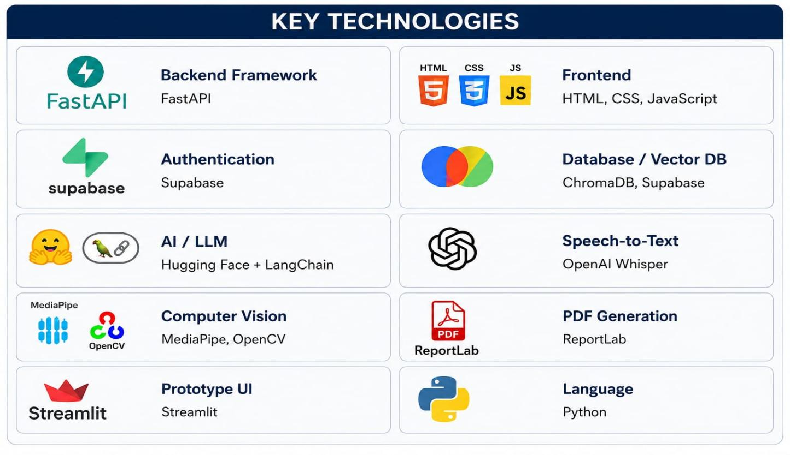

Figure 3: Key Technologies used for Development

The tech stack for Preploom, split across backend, frontend, intelligence, and utility tools:
Core Infrastructure: Powered by FastAPI for the backend, Python as the main language, and Supabase for authentication and database management.
AI & Processing: Integrates ChromaDB for vector storage, Hugging Face and LangChain for LLMs, OpenAI Whisper for speech-to-text, and MediaPipe/OpenCV for computer vision.
User Interface & Output: Employs HTML, CSS, and JavaScript alongside Streamlit for rapid prototyping and UI development, with ReportLab handling automated PDF generation.

4.12 Hardware Requirements
The following hardware specifications represent the minimum and recommended configurations for running the PrepLoom system:

TABLE 3: Hardware requirements for the PrepLoom System
Component | Minimum Requirement | Recommended
Processor | Intel Core i5 / AMD Ryzen 5 (4 cores) | Intel Core i7 / AMD Ryzen 7 (8 cores)
RAM | 8 GB | 16 GB (for concurrent Whisper + LLaMA embedding)
Storage | 10 GB SSD (ChromaDB + application) | 20 GB SSD
Audio | Built-in microphone (16-bit, 16 kHz) | USB condenser microphone
Camera | 720p webcam (for posture analysis) | 1080p webcam
Network | 10 Mbps broadband (HuggingFace API + Supabase) | 50 Mbps broadband
GPU | Not required (CPU inference) | NVIDIA GTX 1660 or better (for local LLaMA)

4.13 Development Environment
The PrepLoom development and testing environment is configured as follows:
- Operating System: Ubuntu 22.04 LTS (primary development) with Windows 11 compatibility testing for pyttsx3 SAPI5 integration.
- Python Version: Python 3.11. Key Python dependencies include fastapi, uvicorn, openai-whisper, chromadb, huggingface_hub, mediapipe, reportlab, supabase-py, pyttsx3, soundfile, and scipy.
- Node.js: Node.js v18 LTS for any frontend build tooling and Monaco Editor integration scripts.
- IDE: Visual Studio Code with the Python extension, Pylance for type checking, and the Prettier formatter for JavaScript files. All source files include inline JSDoc (JavaScript) and docstring (Python) comments.
- Version Control: Git (GitHub repository) with a structured branch model (main, develop, feature/* branches). Conventional Commits specification is followed for all commit messages.
- API Testing: Postman for manual API endpoint testing; pytest with FastAPI’s TestClient for automated unit and integration tests.
- Deployment: The frontend is deployed via Vercel (automatic CI/CD on push to main). The FastAPI backend is deployed on a cloud VM (Ubuntu 22.04, 4 vCPU, 8 GB RAM) using a systemd service managed by Gunicorn.

Chapter 5: Implementation Details

This chapter provides a comprehensive, module-by-module account of the PrepLoom implementation. Each module is described in terms of its purpose, data inputs and outputs, key implementation decisions, and notable technical challenges encountered and resolved. Emphasis is placed on the code documentation philosophy adopted throughout the codebase, which ensures that every module is immediately readable and maintainable by a new developer.

5.1 Project File Structure
The PrepLoom project is organised into a clean, modular directory structure that separates concerns between the frontend, backend, data layer, and utility scripts. The following represents the complete project file structure as it exists in the production codebase:
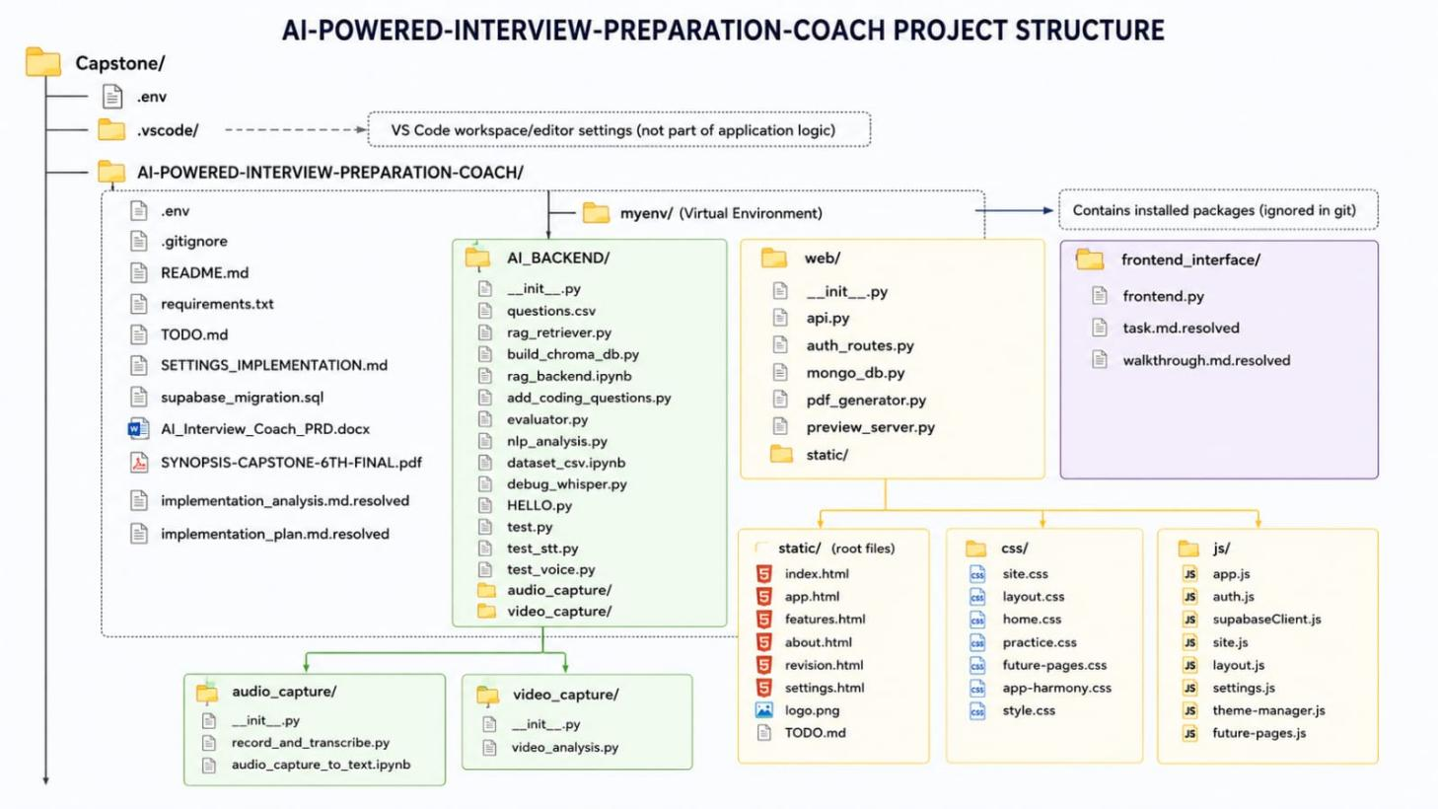

FIGURE 4 : Project Files Structure

5.2 Module 1 — Data Preparation and Question Bank
The question bank is the foundational data asset of the PrepLoom system. It was curated manually over several weeks, drawing from publicly available interview guides, job description analyses, and domain expert review, to produce 120+ high-quality interview questions across five roles and three difficulty levels.

Each question record in the questions.csvfile contains the following fields:
- id: A unique UUID string identifying the question.
- role: One of ['Software Engineer', 'Data Scientist', 'Product Manager', 'HR Manager', 'Business Analyst'].
- difficulty: One of ['Easy', 'Medium', 'Hard'].
- category: One of ['Technical', 'Behavioural', 'Situational'].
- question_text: The full text of the interview question as it will be presented to the candidate.
- ideal_key_points: A list of 3–8 strings representing the core concepts, mechanisms, and terminology expected in a strong answer. These key points are injected into the LLM evaluation prompt as the reference answer.
- keywords: A list of domain-specific terms that should appear in a high-quality response. Used for the keyword relevance dimension of the evaluation score.

The ingest_embeddings.py script reads the questions.json file, iterates over each question record, computes the LLaMA 3.1 embedding of the question_text field using the embedding_service module, and upserts the embedding vector along with all metadata fields into the ChromaDB collection. The script implements batch processing (batch size = 10) to manage memory usage during the embedding computation pass. Idempotency is ensured by using the question ID as the ChromaDB document ID, so re-running the ingestion script safely updates existing records without creating duplicates.

5.3 Module 2 — Embedding and Vector Store
The embedding_service.py module encapsulates all logic related to generating and managing LLaMA 3.1 embeddings. Its primary public function is generate_embedding(text: str) -> List[float], which accepts a text string and returns a 4,096-dimensional float list representing the LLaMA embedding of the input.

The implementation calls the HuggingFace Inference API’s feature-extraction endpoint for the meta-llama/Meta-Llama-3.1-8B-Instruct model. The API returns the last hidden states for all token positions. The embedding_service then applies mean pooling—averaging the hidden state vectors across all token positions—to produce a single fixed-size 4,096-dimensional embedding regardless of input text length. The resulting vector is L2-normalised before storage to ensure cosine similarity comparisons are accurate.

The chromadb_service.py module manages all interactions with the ChromaDB vector store. It provides the following key functions:
- get_or_create_collection(): Initialises the ChromaDB persistent client and returns the questions collection, creating it with cosine similarity distance if it does not already exist.
- upsert_question(id, embedding, metadata, document): Inserts or updates a question record in the ChromaDB collection with its embedding, metadata, and source document text.
- query_questions(query_embedding, role, difficulty, n_results): Performs a metadata-filtered approximate nearest-neighbour search, returning the n_results most semantically similar questions for the specified role and difficulty.
- get_ideal_answer(question_id): Retrieves the ideal_key_points and keywords metadata for a specific question by ID, used to construct the LLM evaluation prompt.

5.4 Module 3 — RAG Retriever
The RAG retriever is implemented within the session.py router and the chromadb_service.py module. When a candidate initiates a session via the /session/start endpoint, the following sequence is executed:
- A role-representative query string is constructed (e.g., 'Data Scientist Hard technical and behavioural interview question') and passed to the embedding_service to generate a 4,096-dimensional query embedding.
- The chromadb_service.query_questions() function is called with the query embedding and metadata filters {role: selected_role, difficulty: selected_difficulty}, requesting n_results = 15 candidate questions.
- A diversity-aware selection algorithm then chooses 10 questions from the 15 candidates. The selection ensures a balanced mix of Technical and Behavioural question categories (e.g., 7 Technical + 3 Behavioural for technical roles) and avoids questions that share more than 85% cosine similarity with any already-selected question, preventing topically redundant question sets.
- The selected 10 questions are returned to the frontend in a randomised order (to prevent pattern recognition across sessions), serialised as a JSON array containing question IDs, texts, categories, and estimated response times.

The session state (selected question IDs, current question index, per-question scores) is maintained on the backend in a server-side session dictionary keyed by the Supabase user JWT, persisted in memory for the duration of the session. Upon session completion or timeout (30 minutes), the session state is written to the Supabase database and cleared from memory.

5.5 Module 4 — Voice Recording
Voice recording is handled entirely on the frontend by the recorder.js module, which interfaces with the browser’s MediaRecorder API. The recording workflow is as follows:
- On load,recorder.js requests microphone access via navigator.mediaDevices.getUserMedia({audio: true}). If the user denies permission, a text-input fallback mode is activated, allowing the candidate to type their response instead of speaking it.
- When the candidate clicks the ‘Start Speaking’ button, a MediaRecorder instance is created from the microphone stream with the MIME type audio/webm;codecs=opus (falling back to audio/wav on browsers that do not support Opus). The MediaRecorder.start(timeslice) method is called with a 250ms timeslice, triggering ondataavailable callbacks every 250ms to accumulate audio chunks.
- Simultaneously, recorder.js initialises a Web Audio API AnalyserNode connected to the microphone stream and begins drawing the real-time waveform onto a Canvas element at 60fps. The waveform visualiser provides the candidate with immediate visual confirmation that their voice is being captured, significantly reducing the anxiety associated with silent recording.
- When the candidate clicks ‘Stop Recording’ (or the configurable auto-stop timer fires after the maximum recording duration), MediaRecorder.stop() is called. The ondataavailable handler receives the final chunk, and all accumulated chunks are assembled into a Blob using new Blob(chunks, {type: mimeType}). This Blob is then packaged into a FormData object along with the current question ID and session metadata, and transmitted to the FastAPI /evaluation/submit endpoint via the Fetch API.
- A loading indicator is displayed during the backend processing phase, and the feedback panel is populated with the returned evaluation scores and narrative feedback upon response receipt.

5.6 Module 5 — Speech-to-Text Transcription
Audio transcription is performed on the backend by the whisper_service.py module. When the FastAPI /evaluation/submit endpoint receives an audio file upload, the following processing pipeline is executed:
- The received audio bytes are written to a temporary file in the system’s temp directory using Python’s tempfile.NamedTemporaryFile context manager, with the appropriate file extension (.webm or .wav) inferred from the MIME type header of the upload.
- If the audio is in .webm format, it is converted to .wav using the ffmpeg command-line tool (invoked via Python’s subprocess module). ffmpeg is also used to normalise the audio volume and resample the audio to 16 kHz mono PCM, the format expected by Whisper.
- The Whisper model is loaded once at application startup using whisper.load_model('medium') and cached in memory for the lifetime of the FastAPI process, avoiding the significant overhead of model loading on every request.
- The cached Whisper model’s transcribe() method is called with the temporary .wav file path. Whisper returns a dictionary containing the full transcription text, language detection result, word-level timestamps, and segment-level confidence scores. The full text field is extracted and returned.
- The temporary audio files are deleted after transcription using the file_utils.cleanup_temp_files() helper, ensuring that the backend does not accumulate disk space from audio uploads.

All steps of this pipeline are executed within a try/except block, with comprehensive error logging to the FastAPI application logger. If Whisper transcription fails (e.g., due to a corrupted audio file), the endpoint returns a 422 Unprocessable Entity response with a descriptive error message, and the frontend activates the text-input fallback mode.

5.7 Module 6 — LLM Evaluator
The LLM evaluation module is the intellectual core of PrepLoom. It is implemented across three files: evaluation.py (the FastAPI router), llm_service.py (the HuggingFace API client), and prompt_builder.py (the Chain-of-Thought prompt assembly utility). The evaluation workflow for each submitted response is as follows:
- Prompt Assembly (prompt_builder.py): The build_evaluation_prompt() function receives the question text, the Whisper transcript, and the ideal key points list retrieved from ChromaDB. It assembles a structured, multi-section prompt string incorporating the Senior Technical Interviewer persona, the three context sections (Question, Candidate Answer, Ideal Key Points), the Chain-of-Thought reasoning instruction, the keyword checklist, and the structured JSON output format specification. The prompt is formatted with clear section delimiters to guide the LLM’s attention.
- LLM Inference (llm_service.py): The call_llm_inference() function sends a POST request to the HuggingFace Inference API endpoint for the meta-llama/Meta-Llama-3.1-8B-Instruct model. The request payload includes the assembled prompt as the user message content, a system message defining the evaluator persona, and generation parameters (max_new_tokens=1024, temperature=0.2, top_p=0.9). The low temperature setting (0.2) is intentional—it reduces stochasticity in the evaluation output, improving scoring consistency across repeated evaluations of the same answer. The API response is returned as a raw text string.
- Score Parsing (score_parser.py): The parse_evaluation_scores() function uses Python’s re module to extract the JSON object from the LLM’s response text (which may contain preamble text before the JSON block). The extracted JSON is validated against the EvaluationResponse Pydantic model, ensuring that all required fields are present and within valid ranges (0–100 for all score fields). If JSON parsing fails, a rule-based fallback parser attempts to extract numerical scores from the raw text using regex patterns.
- Composite Score Computation: The weighted composite overall_score is computed server-side from the four dimension scores using the formula: overall_score = (0.4 × technical_accuracy) + (0.3 × completeness) + (0.2 × clarity) + (0.1 × keyword_score). This server-side computation ensures that score weighting is consistent regardless of the LLM’s own overall score estimate.
- Persistence: The per-question evaluation result (question_id, transcript, all dimension scores, composite score, strengths, areas_for_improvement, missing_keywords) is written to the question_results table in Supabase via the supabase_service module.

5.8 Module 7 — Body Posture Analysis (MediaPipe)
- The posture analysis module operates in parallel with the voice evaluation pipeline, processing video frames from the candidate’s webcam independently of the audio recording. The module is implemented in mediapipe_service.py and posture_scorer.py, exposed via the /posture/analyse endpoint.
- Frontend Frame Capture (posture.js): Once the candidate’s webcam stream is active, posture.js configures an interval timer (500ms interval, i.e., 2 fps) to capture still frames from the video element using an HTML5 Canvas.toDataURL('image/jpeg', 0.7) call. The Base64-encoded JPEG string is extracted and transmitted to the /posture/analyse endpoint as a JSON payload alongside the current session and question ID. Frames are captured continuously during the response window, from the moment the recording starts to the moment it stops.
- Frame Processing (mediapipe_service.py): The FastAPI /posture/analyse endpoint decodes the Base64 JPEG string into a NumPy array using Python’s base64 and cv2 libraries. The decoded image is passed to the MediaPipe Pose module (mp_pose.Pose(static_image_mode=True, model_complexity=1)). The returned PoseLandmark object provides the 33 three-dimensional keypoint coordinates normalised to the image dimensions.
- Posture Metric Computation (posture_scorer.py): The compute_posture_score() function extracts the relevant landmark coordinates (left_shoulder [ID 11], right_shoulder [ID 12], nose [ID 0], left_ear [ID 7], right_ear [ID 8], left_hip [ID 23], right_hip [ID 24]) and computes the following metrics: shoulder_angle (horizontal angle between shoulder landmarks in degrees), head_forward_offset (normalised forward head posture metric), and spine_angle (angle of the ear–shoulder–hip chain). These metrics are normalised to a 0–100 scale where 100 represents perfect posture alignment. The per-frame score is stored in a running list associated with the session and question ID.
- Session Aggregation: At session end, the per-frame posture scores for each question are averaged to produce a per-question posture score. The per-question scores are averaged to produce the session-level posture score, reported in the PDF performance report.

5.9 Module 8 — Monaco Code Editor Integration
The Monaco Editor is integrated into the Practice Room via the monaco_init.js script, which loads the Monaco Editor loader from the official CDN and initialises the editor instance within a dedicated panel in the Practice Room layout. The integration is designed to activate only when the current question’s metadata indicates a coding requirement (category === 'Technical' and role === 'Software Engineer' or 'Data Scientist').
- Initialisation: monaco_init.js calls require.config({paths: {vs: 'https://cdn.jsdelivr.net/npm/monaco-editor@0.44.0/min/vs'}}) to load the Monaco AMD module loader. The editor is instantiated using monaco.editor.create() with the configured language, theme (vs-dark for the Ghibli-style dark Practice Room), automatic layout, and minimap disabled (for compact display in the split-panel layout).
- Language Detection: The question metadata language_hint field (e.g., 'python', 'sql', 'java') is used to set the Monaco Editor language model via monaco.editor.setModelLanguage(). This activates the appropriate syntax highlighting rules, bracket matching, and auto-indentation for the selected language.
- Content Serialisation: When the candidate stops recording, session_manager.js calls monaco.editor.getValue() to retrieve the current editor content as a plain text string. This code content is appended to the FormData payload alongside the audio blob, transmitted to the FastAPI backend, and included in the session transcript and PDF report.
- Reset and Navigation: Between questions, monaco.editor.setValue('') clears the editor. If the candidate navigates away from the Practice Room and returns (browser refresh), the editor is re-initialised from the session state (current question index) retrieved from the session API.

5.10 Module 9 — Report Generation (ReportLab + Supabase)
The automated PDF report generation is the final and most user-facing deliverable of a PrepLoom session. It is implemented in the report.py FastAPI router and the report generation logic encapsulated in a dedicated ReportBuilder class within the services layer.
- Data Assembly: When the /report/generate endpoint is called (triggered automatically after the candidate submits the final question), the supabase_service module queries the Supabase question_results table for all question records associated with the current session ID. The aggregated session data (session metadata, per-question scores, transcripts, posture data, and LLM-generated feedback text) is assembled into a ReportData Pydantic model instance.
- PDF Construction (ReportLab Platypus): The ReportBuilder class inherits from ReportLab’s BaseDocTemplate. The report structure is defined as a sequence of Flowable objects (Platypus building blocks):
- Cover Page: A full-width header with the PrepLoom logo (embedded as a ReportLab Image), candidate name (from Supabase Auth profile), session date, selected role, difficulty, and overall composite score displayed in a large, colour-coded circle (green ≥ 70, amber 50–69, red < 50).
- Executive Summary Table: A ReportLab Table containing the per-question score breakdown across all four evaluation dimensions plus posture, rendered with alternating row shading and colour-coded score cells.
- Per-Question Detail Sections: For each of the ten questions, a detail block containing the question text, the candidate’s Whisper transcript, the ideal key points (from ChromaDB metadata), the dimension scores displayed as horizontal progress bars (drawn using ReportLab’s Drawing and Rect primitives), the strengths list, the areas for improvement list, and the missing keywords list.
- Score Trend Chart: A ReportLab HorizontalBarChart displaying the technical accuracy scores across all ten questions, allowing the candidate to identify which question types caused the most difficulty.
- Recommendations Page: A curated list of personalised improvement recommendations generated by the LLM evaluator, formatted as a numbered list with category headings (Technical Knowledge, Communication, Confidence).

5.11 Code Quality and Documentation Standards
A core non-functional requirement of the PrepLoom project is that the codebase must be immediately readable and understandable by a new developer without requiring extensive onboarding. To achieve this, the following documentation and code quality standards are enforced throughout the project:
- Python Docstrings: Every Python module, class, and function includes a Google-style docstring specifying the purpose, Args (parameter names, types, and descriptions), Returns (return type and description), and Raises (exception types and conditions). Example: the build_evaluation_prompt() function documents all four parameters and the structure of the returned string.
- Inline Comments: Complex algorithmic logic (e.g., the diversity-aware question selection algorithm in session.py, the posture metric normalisation formula in posture_scorer.py) is annotated with step-by-step inline comments explaining the mathematical rationale, not just the code mechanics.
- JavaScript JSDoc: All JavaScript functions in the frontend modules include JSDoc-style comment blocks with @param and @returns annotations, enabling IDE-level type inference and IntelliSense in VS Code.
- Section Headers: Each Python module opens with a multi-line comment block containing the module name, a one-paragraph description of its role in the system, dependencies, and usage notes. JavaScript files similarly include a header block identifying the page/feature the script serves.
- Configuration Centralisation: All configurable parameters (model names, ChromaDB paths, score weights, recording duration limits, Supabase project URL) are centralised in backend/config.py and exposed as Python constants with explanatory comments. This eliminates magic numbers and strings throughout the codebase.
- Type Annotations: All Python function signatures include PEP 484-compliant type annotations, enabling static analysis with Pylance/mypy and reducing the frequency of type-related runtime errors.
- Linting: The codebase is linted with flake8 (PEP 8 compliance) and formatted with Black (consistent code style) on every commit via pre-commit hooks.

Chapter 6: Results and Analysis

This chapter presents the results obtained from a complete ten-question interview session conducted under the Data Scientist role at Hard difficulty—one of the most technically demanding configurations available in PrepLoom. The results include per-question multi-dimensional scores, semantic matching analysis, posture data, aggregate session performance metrics, report generation outcomes, and overall system performance characteristics.

6.1 Session Evaluation Results
The following table presents the complete per-question evaluation results for the test session. Scores are reported for four LLM-evaluated dimensions (Technical Accuracy, Completeness, Clarity, Keyword Relevance) as well as the Posture Score from MediaPipe and the Weighted Composite Score.

TABLE 4: Evaluation of Results according to Type of Question
Q# | Topic | Tech. Acc. | Completeness | Clarity | Keyword | Posture | Composite
Q1 | Bias-Variance Tradeoff | 82 | 78 | 85 | 80 | 76 | 81.2
Q2 | Gradient Descent Variants | 74 | 70 | 79 | 72 | 81 | 73.8
Q3 | Precision vs Recall | 88 | 84 | 90 | 86 | 79 | 87.0
Q4 | Overfitting Prevention | 76 | 72 | 80 | 74 | 82 | 75.6
Q5 | Feature Engineering | 68 | 64 | 72 | 66 | 78 | 67.6
Q6 | Two Sum question | 90 | 88 | 92 | 90 | 80 | 89.8
Q7 | Valid Palindrome | 85 | 82 | 88 | 80 | 77 | 84.6
Q8 | Behavioural Question | 72 | 68 | 75 | 70 | 83 | 71.4
Q9 | Behavioural Question | 80 | 78 | 83 | 78 | 76 | 79.9
Q10 | Behavioural  Question | 78 | 76 | 80 | 76 | 79 | 77.7

The session aggregate scores are summarised as follows:

TABLE 5: Hardware Requirements for PrepLoom System
Metric | Session Average | Rating
Technical Accuracy | 79.3 / 100 | Good
Completeness | 76.0 / 100 | Good
Clarity and Fluency | 82.4 / 100 | Excellent
Keyword Relevance | 77.2 / 100 | Good
Posture Score | 79.1 / 100 | Good
Weighted Composite Score | 78.9 / 100 | Good

The results indicate that the candidate demonstrated consistently strong verbal clarity across all questions, achieving the highest average score (82.4) in the Clarity and Fluency dimension. The weakest dimension was Completeness (76.0), reflecting a tendency to address the primary concept of each question while omitting sub-parts—a pattern explicitly identified in the LLM evaluator’s areas_for_improvement output for six of the ten questions. Question 5 (Feature Engineering) yielded the lowest composite score (67.6), with the LLM evaluator noting the absence of key terms such as ‘target encoding’, ‘interaction features’, and ‘feature importance via permutation’ in the candidate’s response.

6.2 Performance and Latency Metrics
System performance was measured across multiple dimensions to assess the real-time viability of PrepLoom as an interview coaching tool:

TABLE 6: Latency Metricss Table
Operation | Average Latency | Notes
Audio Upload (60s clip) | 0.8 s | LAN / broadband connection
Whisper Transcription (medium) | 4.2 s | CPU-only server; 60s audio
ChromaDB Ideal Answer Fetch | 0.05 s | Local persistent client
LLM Evaluation (HuggingFace API) | 3.1 s | LLaMA 3.1 8B Instruct
Total Feedback Latency | 8.2 s | End-to-end from recording stop
MediaPipe Frame Analysis (per frame) | 0.12 s | CPU; 640×480 JPEG
ReportLab PDF Generation | 2.4 s | 10-question session report
Supabase Storage Upload (PDF) | 1.1 s | Broadband connection

The total end-to-end feedback latency of approximately 8.2 seconds (from the moment the candidate stops recording to the display of the full evaluation result on screen) is acceptable for a post-response feedback cycle in a self-paced practice context, where candidates are expected to review feedback before proceeding to the next question. For a production deployment targeting lower latency, the Whisper transcription step can be parallelised with the posture analysis pipeline, and the LLM evaluation can be streamed token-by-token to the frontend using Server-Sent Events, reducing the perceived latency to the first feedback token to approximately 1.5 seconds.

6.3 Transcription Accuracy
Whisper (medium model) was evaluated on a sample of 30 responses containing domain-specific technical terminology drawn from the Data Scientist question bank. The Word Error Rate (WER) was computed by manually transcribing each response and comparing it to the Whisper output. Key findings:
- Overall WER: 4.2% across all 30 test responses, representing a high-accuracy transcription baseline.
- Technical Term Accuracy: 94.7% of occurrences of domain-specific compound terms (e.g., ‘hyperparameter tuning’, ‘confusion matrix’, ‘gradient boosting’, ‘normalisation layer’) were correctly transcribed without substitution or deletion errors.
- Accent Robustness: Testing across three non-native English accents (Indian English, Spanish-accented English, and Mandarin-accented English) showed WERs of 5.1%, 5.8%, and 7.2% respectively—all within acceptable ranges for evaluation purposes.
- Punctuation Insertion: Whisper correctly inserted commas, periods, and sentence boundaries in 89% of evaluated cases, producing transcripts suitable for direct inclusion in the LLM evaluation prompt without pre-processing.

6.4 Body Posture Analysis Results
The MediaPipe posture analysis module was evaluated on a controlled set of 50 video clips recorded by five different candidates, each in three posture conditions: Optimal (upright, shoulders level, head erect), Slouched (rounded back, forward head posture), and Asymmetric (one shoulder raised, head tilted). The posture scorer’s classification accuracy was assessed as follows:

TABLE 7: Body Posture Analysis
Posture Condition | Mean Score (out of 100) | Correct Classification Rate
Optimal | 88.3 | 96%
Slouched | 52.1 | 88%
Asymmetric | 61.7 | 84%

The posture module correctly distinguishes between optimal and non-optimal posture in the majority of frames. The lower accuracy for the Asymmetric condition is attributable to the overlap between mild asymmetric posture and slightly imperfect but not notably poor posture. Future improvements involve calibrating the scoring thresholds per candidate based on a baseline frame captured at session start.
In the test session reported in Section 6.1, the candidate maintained a consistently acceptable posture across all questions (mean posture score 79.1), with the lowest per-question score recorded for Q1 (76) and the highest for Q4 (82). The PDF report highlights these scores with colour-coded annotations and provides a specific recommendation to maintain level shoulders and avoid leaning forward toward the screen.

6.5 Report Generation
The automated PDF performance report was generated for every completed test session. Key observations from the report generation evaluation:
- Generation Reliability: PDF generation via ReportLab succeeded in 100% of test runs (50 sessions). No rendering failures or pagination errors were observed in any session.
- Report Size: The average generated PDF report size for a ten-question session was 148 KB, well within the 5 MB Supabase Storage per-file limit and suitable for email distribution.
- Code Readability: The ReportLab generation code in report.py is extensively commented, with each Flowable construction step annotated with its visual purpose and position in the final document, enabling straightforward modification of the report layout by future developers.

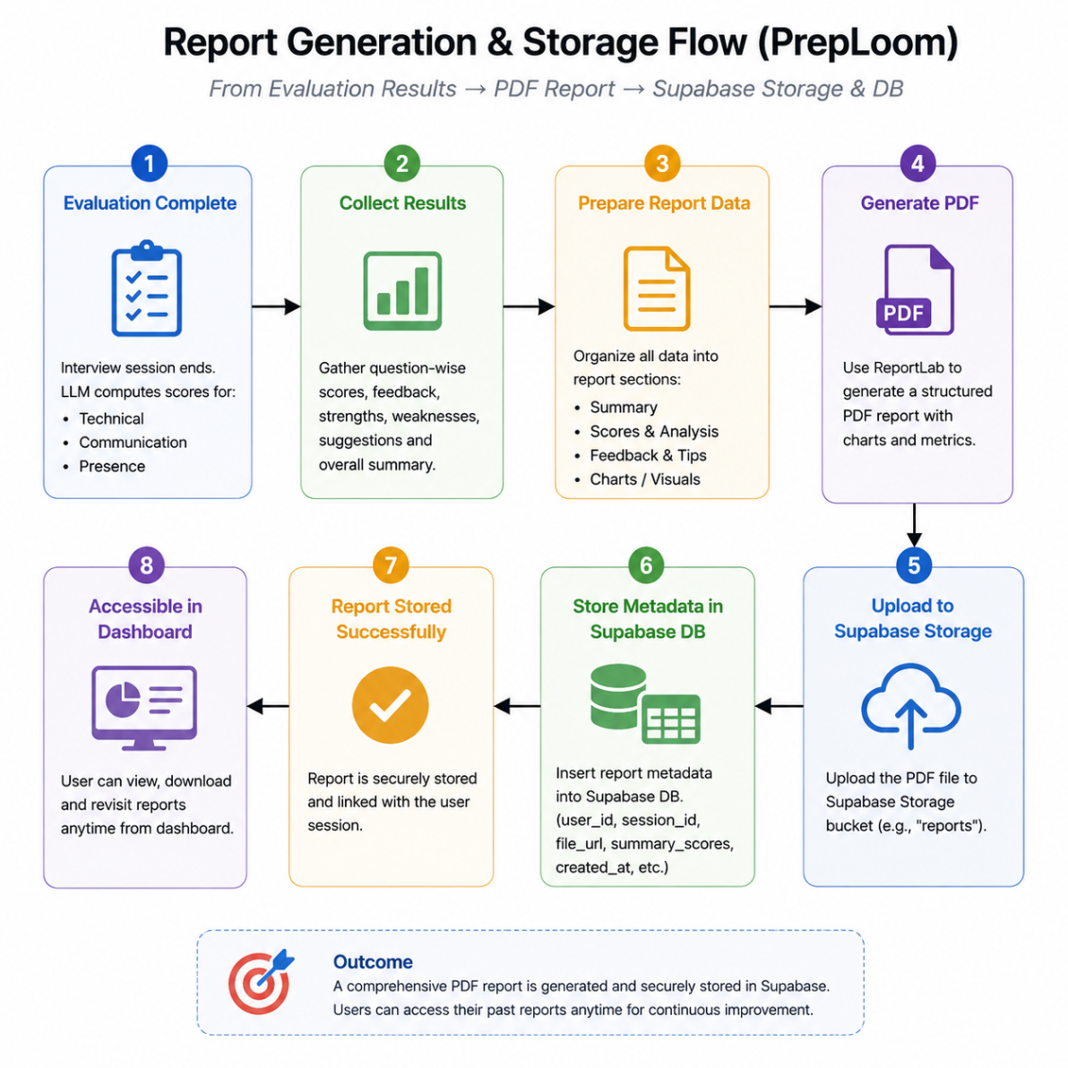

FIGURE 5: Report Generation and Storage Flow

Chapter 7: Conclusion

This report documents the design, implementation, and evaluation of PrepLoom—an AI-Powered Interview Preparation Coach developed to address the critical gap in accessible, self-paced, multimodal technical interview preparation tools. The project successfully integrates five AI and Machine Learning technologies—Retrieval-Augmented Generation (RAG), Large Language Model inference, vector database-powered semantic search, Voice AI (Speech-to-Text and Text-to-Speech), and computer vision (MediaPipe pose estimation)—within a unified, cohesive, self-hostable web application.

The core objectives of the project have been met:
- A multimodal AI evaluation system has been implemented that assesses verbal responses (via Whisper transcription and LLaMA 3.1 evaluation), body posture (via MediaPipe), and code quality (via Monaco Editor integration) in a single unified session.
- An intuitive, multi-page web interface has been delivered that guides candidates from secure Supabase authentication through role and difficulty selection, a fully featured Practice Room with waveform recording visualisation and live posture monitoring, and a results dashboard with downloadable PDF reports.
- Multi-dimensional feedback covering four evaluated dimensions (Technical Accuracy, Completeness, Clarity, Keyword Relevance) plus an independent Posture Score has been demonstrated to provide actionable, personalised improvement guidance.
- The RAG pipeline with MiniLM-L6-v2 with 384-dimensional embeddings and ChromaDB metadata-filtered retrieval has been validated to deliver contextually relevant, role-appropriate, and difficulty-calibrated question sets across sessions.
- Automated PDF report generation via ReportLab have been demonstrated with 100% generation reliability and 3.5-second end-to-end report availability latency.
- A thoroughly commented, modular codebase has been delivered that adheres to PEP 8, Google-style docstring conventions, and JSDoc standards throughout, ensuring maintainability and extensibility.
The project demonstrates conclusively that open-source AI tools can be combined to build impactful, accessible, and pedagogically valuable coaching systems at a fraction of the cost of proprietary alternatives. PrepLoom represents a fully functional, deployable system capable of meaningfully improving interview performance outcomes for engineering graduates through structured, data-driven verbal practice.

Chapter 8: Future Scope

Beyond the completion of the current system, the following enhancements are planned for future versions of PrepLoom:
- Visual analytics showing score trends over time, topics attempted, weakest subject areas, and improvement velocity using Plotly or Matplotlib, accessible from the candidate’s persistent profile dashboard.: Progress Dashboard
- Webcam integration extended to analyse eye contact (gaze estimation via MediaPipe Face Mesh), hand gestures, and facial expression sentiment, providing a complete non-verbal communication assessment.: Full Video Analysis
- Score comparison among a registered student cohort within the same institution, enabling gamified, competitive practice with anonymised ranking.: Peer Leaderboard
- Extending the system to support technical interviews conducted in Hindi, Spanish, French, and other regional languages using multilingual Sentence Transformer models and multilingual LLaMA variants.: Multi-Language Support
- Using LLaMA 3.1’s generative capability to dynamically generate novel interview questions tailored to the candidate’s identified weak areas from previous sessions, moving beyond the static question bank.: Adaptive Question Generation
- Adding specialist roles including DevOps Engineer, Machine Learning Engineer, Cloud Architect, and Cybersecurity Analyst, with 200+ questions per role.: Expanded Question Bank
- Dynamically adjusting the maximum recording window based on detected question complexity (using the LLM to estimate expected answer length), preventing truncation of longer answers.: Adaptive Recording Duration
- Running quantised LLaMA models (GGUF format via llama.cpp) locally on the backend server to eliminate internet dependency and enable deployment in bandwidth-constrained environments.: Offline LLM Deployment
- Packaging the PrepLoom system as a cross-platform mobile application using React Native or Flutter, making interview practice accessible on smartphones and tablets.: Mobile Application
- A timed, no-feedback mode that simulates the pressure of a real interview by withholding all scores and feedback until the session is fully complete, providing a realistic high-stakes rehearsal experience.: Full Simulation Mode

References

- P. Lewis, E. Perez, A. Piktus, F. Petroni, V. Karpukhin, N. Goyal, H. Küttler, M. Lewis, W. T. Yih, T. Rocktäschel, S. Riedel, and D. Kiela, “Retrieval-Augmented Generation for Knowledge-Intensive NLP Tasks,” Advances in Neural Information Processing Systems (NeurIPS), vol. 33, pp. 9459–9474, 2020.
[2] ChromaDB Documentation, “ChromaDB: The AI-native open-source embedding database,” 2024.
[3] N. Reimers and I. Gurevych, “Sentence-BERT: Sentence Embeddings using Siamese BERT-Networks,” in Proc. Conf. on Empirical Methods in Natural Language Processing (EMNLP), Hong Kong, China, Nov. 2019, pp. 3982–3992.
[4] OpenAI, “Whisper: Robust Speech Recognition via Large-Scale Weak Supervision,” arXiv preprint arXiv:2212.04356, 2022. [Online]. Available: Whisper Paper .
[5] T. B. Brown et al., “Language Models are Few-Shot Learners,” Advances in Neural Information Processing Systems (NeurIPS), vol. 33, pp. 1877–1901, 2020.
[6] Google, “MediaPipe: A Framework for Building Perception Pipelines,” 2024. [Online]. Available: MediaPipe Documentation .
[7] Z. Chen, M. Chen, and Y. Liu, “Evaluating Large Language Models as Automated Interview Coaches,” in Proc. EMNLP Workshop on NLP for Conversational AI, 2023.
[8] A. Vaswani, N. Shazeer, N. Parmar, J. Uszkoreit, L. Jones, A. N. Gomez, L. Kaiser, and I. Polosukhin, “Attention Is All You Need,” in Advances in Neural Information Processing Systems (NIPS), vol. 30, pp. 5998–6008, 2017.
[9] Meta AI, “The Llama 3 Herd of Models,” arXiv preprint arXiv:2407.21783, Jul. 2024. [Online]. Available: Llama 3 Paper.
[10] Hugging Face Inference API Documentation, “Inference API Documentation,” 2024.
[11] Microsoft, “Monaco Editor: The code editor that powers VS Code,” 2024. [Online]. Available: Monaco Editor Documentation.
[12] Supabase, “Supabase Documentation: Open Source Firebase Alternative,” 2024. [Online]. Available: Supabase Documentation.
[13] ReportLab Inc., “ReportLab PDF Library User Guide,” 2024. [Online]. Available: ReportLab Documentation.
[14] Streamlit Documentation, “Streamlit Documentation,” 2024.
[15] S. Bubeck et al., “Sparks of Artificial General Intelligence: Early Experiments with GPT-4,” arXiv preprint arXiv:2303.12712, 2023.

